Types of inheritance in java
On the basis of class, there can be three types of inheritance in java: single, multilevel and hierarchical.
In java programming, multiple and hybrid inheritance is supported through interface only. We will learn about interfaces later.
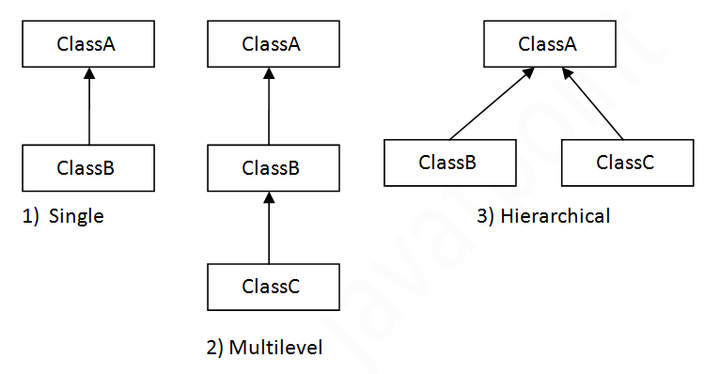

Note: Multiple inheritance is not supported in Java through class.
When one class inherits multiple classes, it is known as multiple inheritance. For Example:

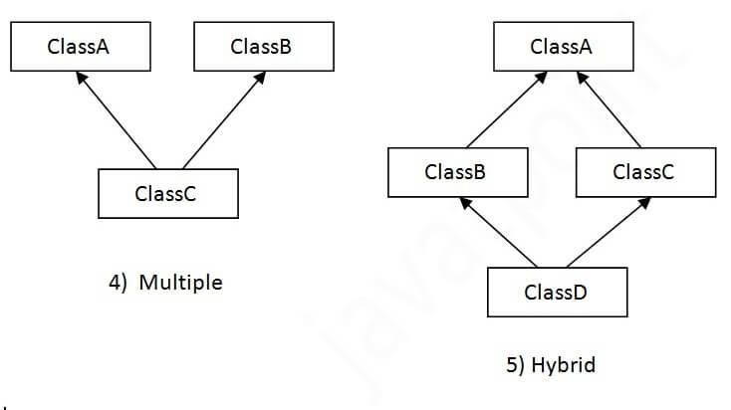

What is inheritance?
Inheritance is the mechanism that allows programmers to create new classes from existing class. By using inhertitance programmers can re-use code they've already written.
Any new class that you create from an existing class is called sub class; existing class is called super class.
The sub class gets all of the methods and state variables of the super class by default. The sub class can add new methods and state variables. The sub class can also redefine methods and state variables of its parent.
Let's understand these concept by an example :
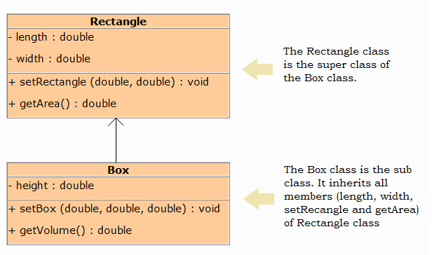
The following rules about superclasses and subclasses should be kept in mind:
- All data members of the superclass are also data members of the subclass. Similarly, the methods of the superclass are also the methods of the subclass.
- The private members of the superclass cannot be accessed by the members of the subclass directly.
- The subclass can directly access the public members of the superclass.
Following program illustrate this :

(Rectangle.java)
/**
* Rectangle class using as super class.
*/
publicclassRectangle
{
privatedouble length; //To hold length
privatedouble width; //To hold width

/**
* Sets length and width of rectangle
*/
publicvoidsetRectangle(double length, double width)
{
this.length = length;
this.width = width;
}

/**
* Returns area of rectangle
*/
publicdoublegetArea()
{
return length * width;
}
}
(Box.java)
/**
* The class Box extending Rectangle class.
*/
publicclassBoxextendsRectangle
{
privatedouble height; //To hold height

/**
* Sets length, width and heigth of box
*/
publicvoidsetBox(double length, double width, double height)
{
// Call the inherited setRectangle method
// to set length and width of box.
setRectangle(length,width);
this.height = height;
}

/**
* Returns volume of cube
*/
publicdoublegetVolume()
{
//Call the inherited getArea method
returngetArea() * height;
}
}
(BoxDemo.java)
/**
* This program demonstrates the Box class, which
* inherits from the Rectangle class.
*/
publicclassBoxDemo
{
publicstaticvoidmain(String[] args)
{
// Create a Box object.
Box room = new Box();

// Set values in Box object.
room.setBox(12.5, 10.5, 9.5);

// Display the volume.
System.out.println("Volume is " + room.getVolume());
}
}
Output :
Volume is 1246.875

Calling the Superclass Constructor
A subclass can have its own private data members, so a subclass can also have its own constructors.
The constructors of the subclass can initialize only the instance variables of the subclass. Thus, when a subclass object is instantiated the subclass object must also automatically execute one of the constructors of the superclass.
To call a superclass constructor the super keyword is used. The following example programs demonstrate use of super keyword.
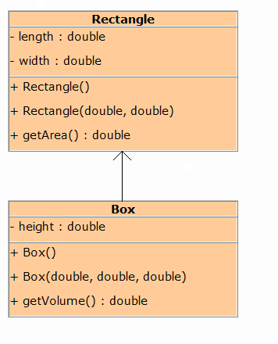
(Rectangle.java)
/**
* This class holds data of a Rectangle.
*/

publicclassRectangle
{
privatedouble length; // To hold length of rectangle
privatedouble width; // To hold width of rectangle

/**
* The constructor initialize rectangle's
* length and width with default value
*/

publicRectangle()
{
length = 0;
width = 0;
}

/**
* The constructor accepts the rectangle's
* length and width.
*/

publicRectangle(double length, double width)
{
this.length = length;
this.width = width;
}

/**
* The getArea method returns the area of
* the rectangle.
*/

publicdoublegetArea()
{
return length * width;
}
}
(Box.java)
/**
* This class holds data of a Box.
*/

publicclassBoxextendsRectangle
{
privatedouble height; // To hold height of the box

/**
* The constructor initialize box's
* length, width and height with default value.
*/

publicBox()
{
// Call the superclass default constructor to
// initialize length and width.
super();
//Initialize height.
height = 0;
}

/**
* The constructor accepts the box's
* length, width and height.
*/

publicBox(double length, double width, double height)
{
// Call the superclass constructor to
// initialize length and width.
super(length, width);

// Initialize height.
this.height = height;
}

/**
* The getVolume method returns the volume of
* the box.
*/

publicdoublegetVolume()
{
returngetArea() * height;
}
}
(BoxDemo.java)
/**
* This program demonstrates calling
* of superclass constructor.
*/

publicclassBoxDemo
{
publicstaticvoidmain(String[] args)
{
// Create a box object.
Box myBox1 = new Box();

// Display the volume of myBox1.
System.out.println("Volume: " + myBox1.getVolume());

// Create a box object.
Box myBox2 = new Box(12.2, 3.5, 2.0);

// Display the volume of myBox2.
System.out.println("Volume: " + myBox1.getVolume());
}
}

Overriding Superclass Methods
In a class hierarchy, when a method in a subclass has the same name and type signature as a method in its superclass, then the method in the subclass is said to override the method in the superclass. When an overridden method is called from within a subclass, it will always refer to the version of that method defined by the subclass. The version of the method defined by the superclass will be hidden.
A subclass may call an overridden superclass method by prefixing its name with the super key word and a dot (.). Consider the following:
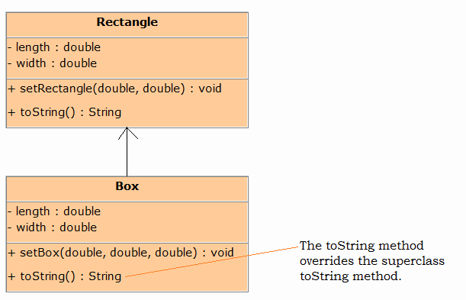
Program (Rectangle.java)
publicclassRectangle
{
privatedouble length;
privatedouble width;

/**
* Sets length and width of rectangle.
*/
publicvoidsetRectangle(double length, double width)
{
this.length = length;
this.width = width;
}

/**
* Returns length and width as string
*/
public String toString()
{
return"Length : " + length + "\nWidth : " + width;
}
}
Program (Box.java)
publicclassBoxextendsRectangle
{
privatedouble height;

/**
* Sets length, width and height of box.
*/
publicvoidsetBox(double length, double width, double height)
{
setRectangle(length, width);
this.height = height;
}

/**
* The toString method overrides the Rectangle's toString method
* and returns length, width and height of box as string
*/
public String toString()
{
Return super.toString() + //Calling Rectangle's toString method
"\nHeight : " + height;
}
}
Program (BoxDemo.java)
importjava.util.Scanner;

/**
* This program demonstrates the Box class.
*/

publicclassBoxDemo
{
publicstaticvoidmain(String[] args)
{
double length, width, height;

// Create a Scanner object for keybaord input.
Scanner console = new Scanner(System.in);

// Get the length of box.
System.out.print("Enter the length of box : ");
length = console.nextDouble();

// Get the width of box.
System.out.print("Enter the width of box : ");
width = console.nextDouble();

// Get the height of box.
System.out.print("Enter the height of box : ");
height = console.nextDouble();

// Create a box object.
Box myBox = new Box();

// Set the length, width and height of box.
myBox.setBox(length, width, height);

// Display the box detalis.
System.out.println(myBox);
}
}
Output :
Enter the length of box : 34.5
Enter the width of box : 5.6
Enter the height of box : 3.2
Length : 34.5
Width : 5.6
Height : 3.2

Protected Member
The private members of a class cannot be directly accessed outside the class. Only methods of that class can access the private members directly. As discussed previously, however, sometimes it may be necessary for a subclass to access a private member of a superclass. If you make a private member public, then anyone can access that member. So, if a member of a superclass needs to be (directly) accessed in a subclass and yet still prevent its direct access outside the class, you must declare that member protected.
Following table describes the difference
Modifier | Class | Subclass | World
public | Y | Y | Y
protected | Y | Y | N
private | Y | N | N
Following program illustrates how the methods of a subclass can directly access a protected member of the superclass.
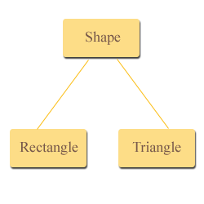
For example, let's imagine a series of classes to describe two kinds of shapes: rectangles and triangles. These two shapes have certain common properties height and a width (or base).
This could be represented in the world of classes with a class Shapes from which we would derive the two other ones : Rectangle and Triangle

Program : (Shape.java)
/**
* A class Shape that holds width and height
* of any shape
*/
publicclassShape
{
protecteddouble height; // To hold height.
protecteddouble width; //To hold width or base

/**
* The setValue method sets the data
* in the height and width field.
*/
publicvoidsetValues(double height, double width)
{
this.height = height;
this.width = width;
}
}
Program : (Rectangle.java)
/**
* This class Rectangle calculates
* the area of rectangle
*/
publicclassRectangleextendsShape
{

/**
* The method returns the area
* of rectangle.
*/
publicdoublegetArea()
{
return height * width; //accessing protected members
}
}
Program : (Triangle.java)
/**
* This class Triangle calculates
* the area of triangle
*/
publicclassTriangleextendsShape
{

/**
* The method returns the area
* of triangle.
*/
publicdoublegetArea()
{
return height * width / 2; //accessing protected members
}
}
Program : (TestProgram.java)
/**
* This program demonstrates the Rectangle and
* Triangle class, which inherits from the Shape class.
*/
publicclassTestProgram
{
publicstaticvoidmain(String[] args)
{
//Create object of Rectangle.
Rectangle rectangle = new Rectangle();

//Create object of Triangle.
Triangle triangle = new Triangle();

//Set values in rectangle object
rectangle.setValues(5,4);

//Set values in trianlge object
triangle.setValues(5,10);

// Display the area of rectangle.
System.out.println("Area of rectangle : " +
rectangle.getArea());

// Display the area of triangle.
System.out.println("Area of triangle : " +
triangle.getArea());
}
}
Output :
Area of rectangle : 20.0
Area of triangle : 25.0

Multilevel Inheritance
In multilevel inheritance a subclass is inherited from another subclass as shown in the figure.
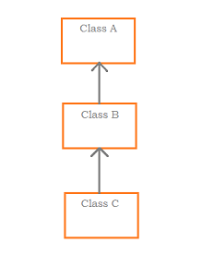
The class A serves as a super class for the sub class B, which in turn serves as a super class for the sub class C. The class B is known as intermediate super class since it provides a link for the inheritance between A and C. The chain ABC is known as inheritance path.
publicclassA
{
......
......
}

publicclassBextendsA
{
......
......
}

publicclassCextendsB
{
......
......
}

